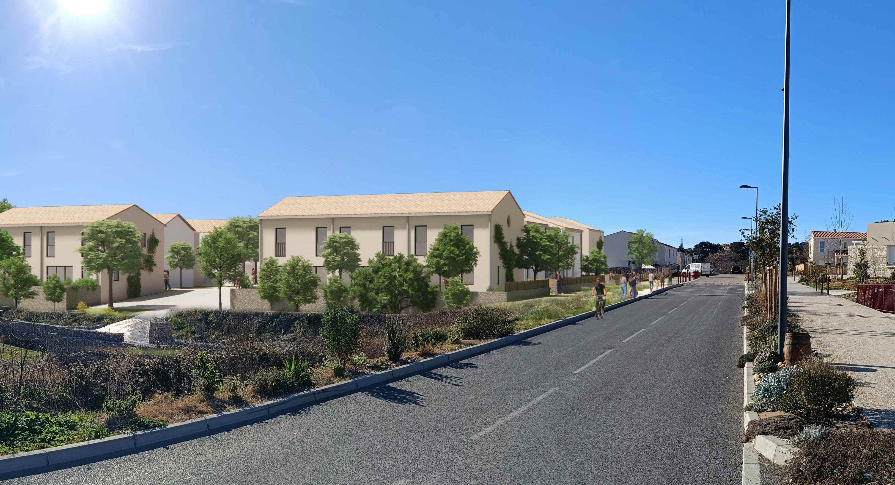

|  |  |  |  |  |  |  |  |
| --- | --- | --- | --- | --- | --- | --- | --- |
| **OPERATION:** | **MAITRISE D'OUVRAGE:** | **MAITRISE D'OEUVRE:** | **PHASE:** | **DATE:** | **ECHELLE:** | **PLAN:** | **PC 6 - Insertion** |
| **Les Saliniers sud Murviel-les-Montpellier** | **Homaya**  34170 Castelnau-Le-Lez  Tél: 06 75 69 64 77  E-mail: [jdestouches@homaya.fr](mailto:jdestouches@homaya.fr) | EXM Architectes  1 rue Chamayou, 34090 Montpellier,  M: 06.22.29.66.25 - T. 04.34.08.27.95  [nb@exm-architectes.com](mailto:nb@exm-architectes.com) |  | 27 mai 2024 |  |